**Deliverable Title**





Deliverable

DX.X

This project has received funding from the European Union’s Horizon 2020 research and innovation programme under grant agreement No. 870708

This project has received funding from the European Union’s Horizon 2020 research and innovation programme under grant agreement No. 870708

**Deliverable Dx.x**

**Title: Deliverable Title**

**Due date:** Month & Year

**Submission date:** Month & Year

**Approved by Leader of Work Package:** Name WP Leader (Institution)

**Type:** See List of deliverables in Annex 1 (part A) of Grant Agreement

**Author List:** Name (Institution)

Name (Institution)

Name (Institution)

Name (Institution)

Name (Institution)

Name (Institution)

Name (Institution)

Name (Institution)

Name (Institution)

­

|  |  |  |  |
| --- | --- | --- | --- |
| **Dissemination Level** | | | |
|  |  | **PU:** | Public |
|  |  | **CO:** | Confidential, only for members of the consortium (including the Commission Services) |

**A**

# Abstract

Please describe the Deliverable here. The aim of this summary is to describe the work done, the results and their interest.

This summary will be public and addressed to a broad public interested in aquaculture, so please remember to use a language which is accessible to that public.

The recommended extension of this summary is 250-500 words (Calibri 11)

**C**

# Contents

Abstract 1

Contents 2

Heading 1 for the Deliverable (Open Sans 28) 1

1.1. Heading 2 for the deliverable (Open Sans 14 bold) 1

Annex 1. Title 4

**01**

# Heading 1 for the Deliverable (Open Sans 28)

Text in Calibri 11

Information about the Deliverable or how it was achieved can be inserted here.

Consider including information about how the Deliverbale relates to overall goals and objectives of the project.

1.1. Heading 2 for the deliverable (Open Sans 14 bold)

Xxxxxxxxxxxxxx

1.1.1. Heading 3 (Open Sans 12 bold)

It does not go to the Table of Contents

***Heading 4***

**Lists**

You can use the headings to organize your text.

1. **Numbered lists.** Use this format for numbered lists.

* **Bulleted lists**. Use this format for bulleted lists.

**Figures and Tables**

Please take into account the following rules when elaborating your tables and figures:

* quote all the figures and the tables in the text,
* number figures and tables from 1 to n,
* indicate the unites you are using,
* tables numbers must be easily legible; consider using landscape orientation for wide tables,
* do not cut tables or figures between two pages; if a table is too long, divide it and insert a header (Table n, cont.) in the following page,
* format the original digital files in such a way as to ensure good quality reproduction, particularly in the case of pictures and figures,
* table headers and figures feet are in Calibri 11 bold

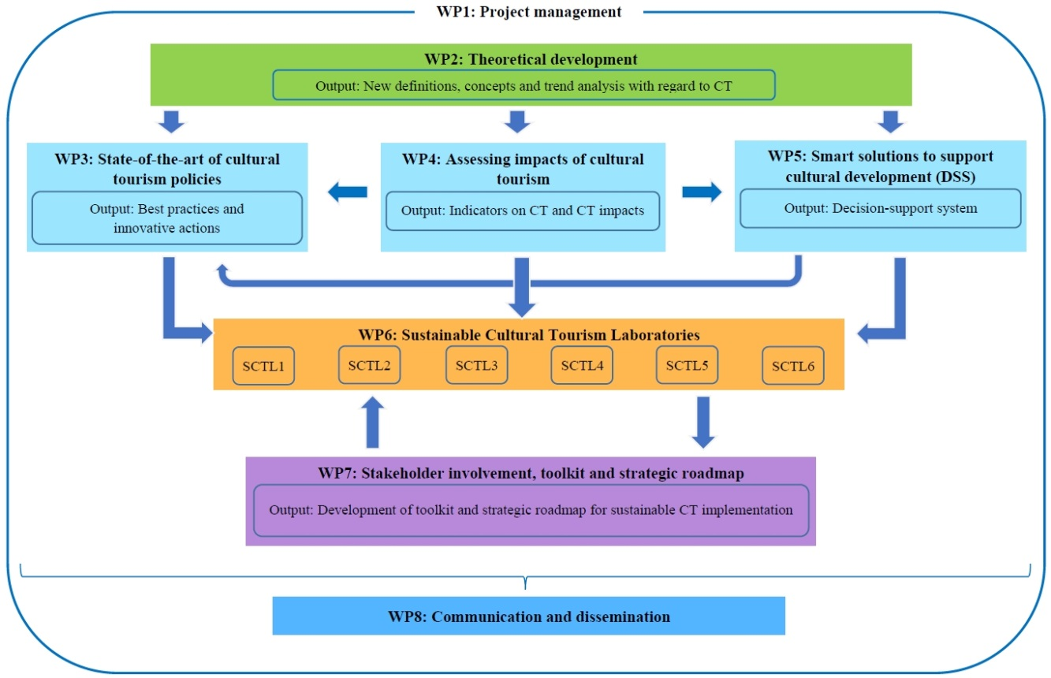

**Fig 1. SmartCulTour Work Packages**

**Table 2. SmartCulTour working meetings**

|  |  |  |
| --- | --- | --- |
| Meeting | Frequency | Type |
| Team meetings | As necessary | To be decided by teams (face to face + tele-conference) |
| Task meetings | As necessary (to be decided by Task leader) | To be decided by leader (face to face + tele-conference) |
| WP meetings | As necessary (to be decided by WP leader). Separate WP meetings will be scheduled in project General Meetings | To be decided by leader (face to face + tele-conference) |
| Executive Board Meetings | Bi-monthly + during project General Meetings  Extraordinary meetings may be convened | Normally by tele-conference  Face to face at General Meetings and in extraordinary cases |
| General Meetings  (incl. Gen. Assembly meetings) | Annually  Extraordinary meetings may be convened | Face to face  (Extraordinary meetings may be organised through tele-conference) |
| Other coordination meetings | If needed, profiting the organisation of project dissemination events | Face to face |

**A1**

# Annex 1. Title

Text in Calibri 11